Simulation/Verification of CCU
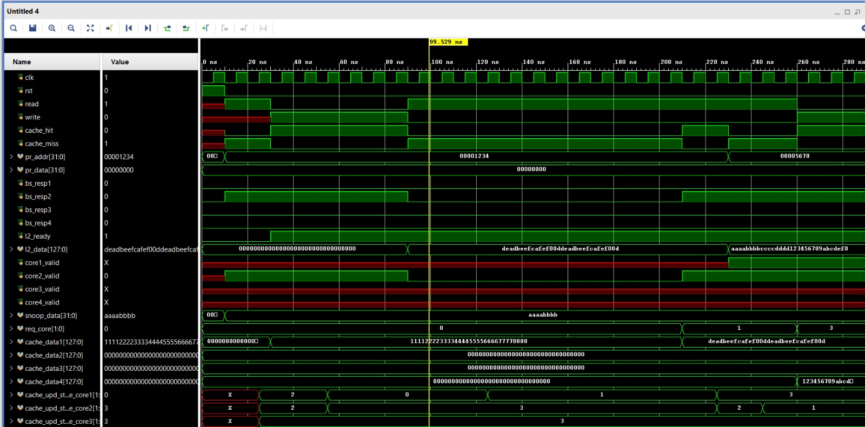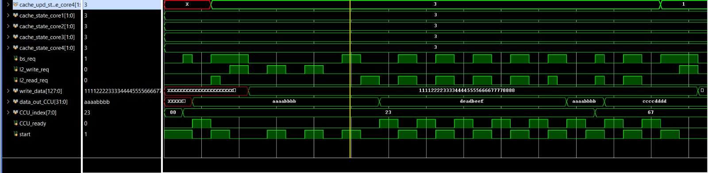
All Tests Passed!

